**Python Assignment Questions**

**Questions on String**

Let's take the following string

" I am very keen in building up my career in Data Science, but not sure from where to start. If I search the web it throws me thousands of articles, few are relevant others make me confused, again I come around to the same page. Supervised has provided me a good platform to remove all such qualms which were wrangling in my mind"

1. Consider the above text as a string, figure out the average length of the string.

Solution:

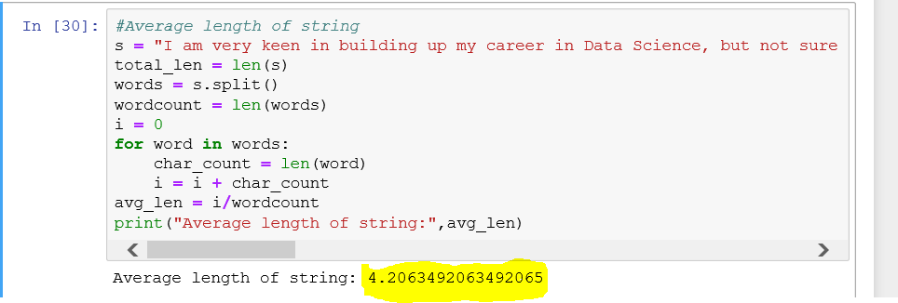

1. Lower the text in the string.

Solution:

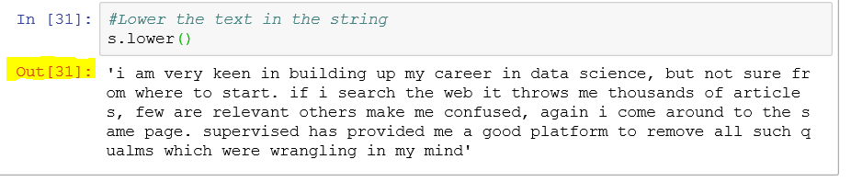

1. Try to get the clean text removing the punctuation from the string.

Solution: 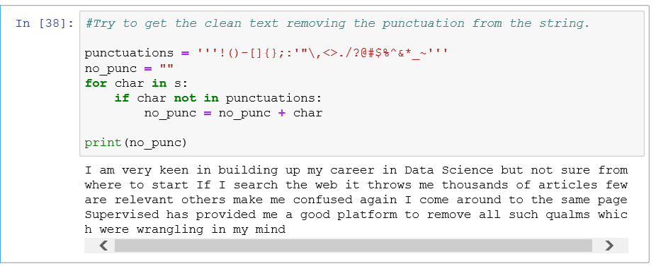

1. Extract word "Data Science" from the string.

Solution:

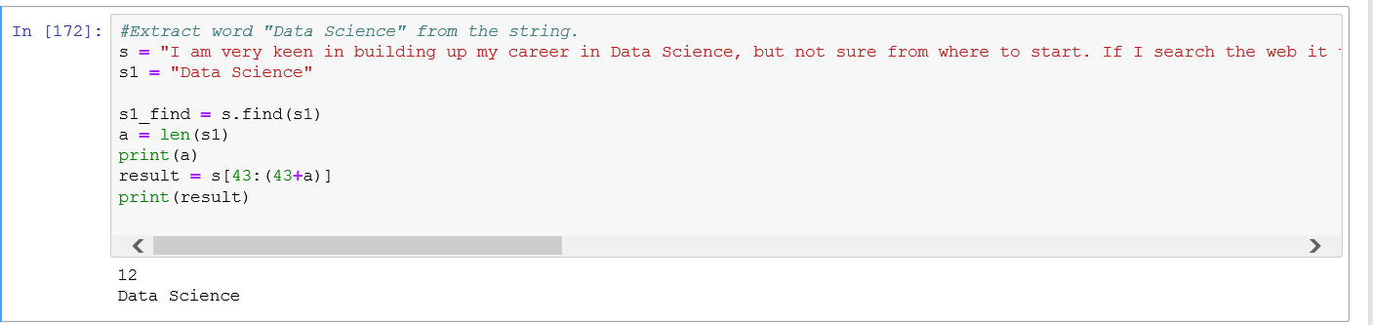

1. Find the frequency of words used in the string.

Solution:

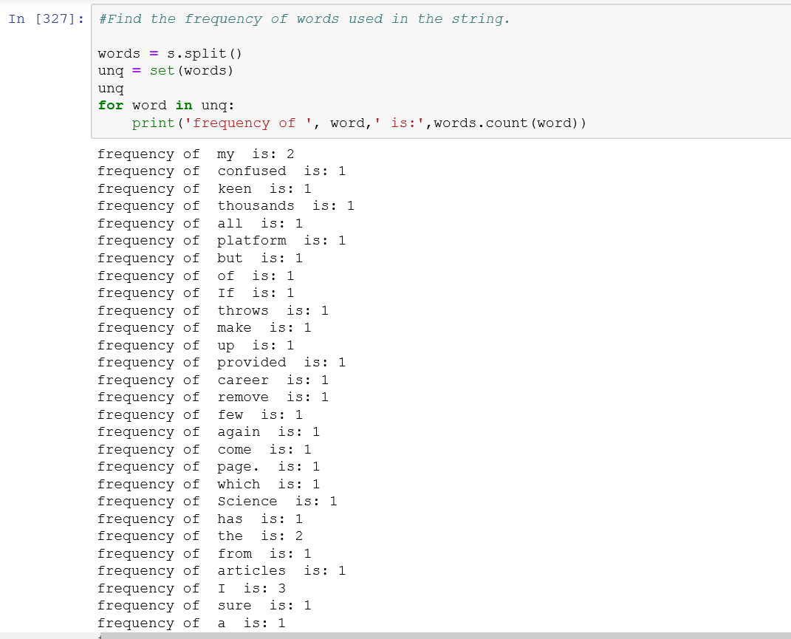

1. Fetch the duplicate pairs used in the string.

Solution:

1. Can you change the word "Supervised" to "Unsupervised" in the string

Solution:

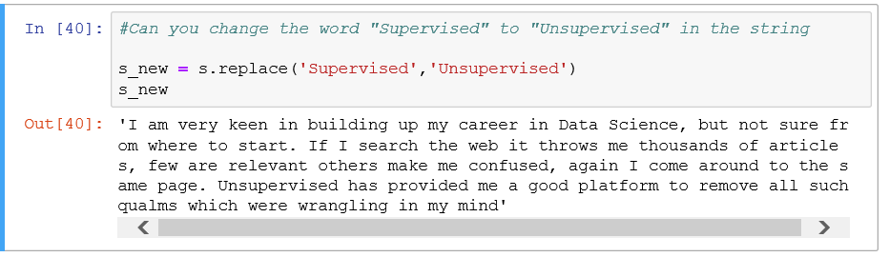

1. Splitting of the string with a dot operator(.)

Solution:

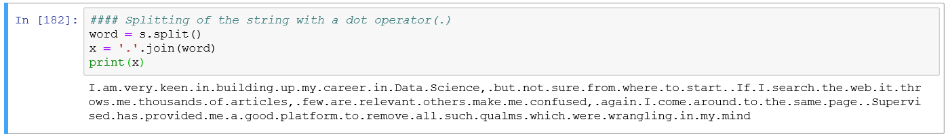

1. Find the words from the string which ends with "e"

Solution:

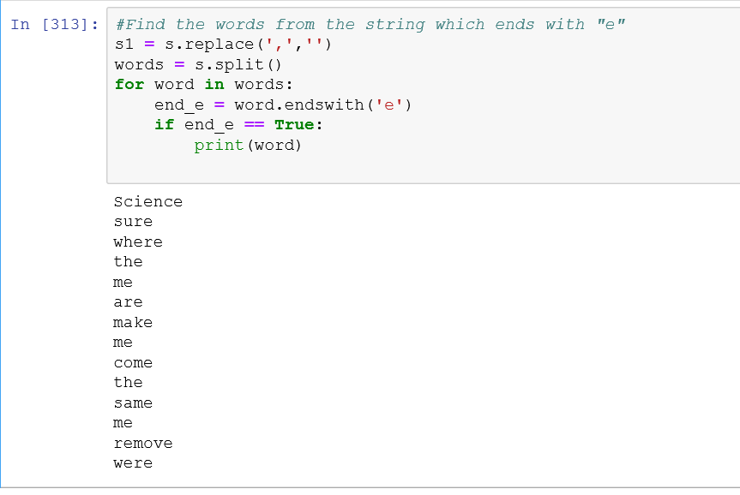

1. Figure out number of a's used in the string.

Solution:

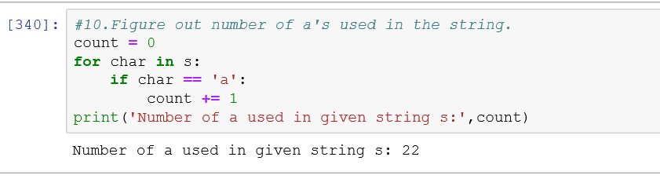

**Questions on Dictionary**

**In the weekend , I purchased 250g of apple, 500g of sugar, 2.5 kg of rice, 2.5 litres of milk and finally 1 dozen of egg.**

1. Can you help me frame the above purchase in the form of dictionary with commodities as keys to it.

Solution:

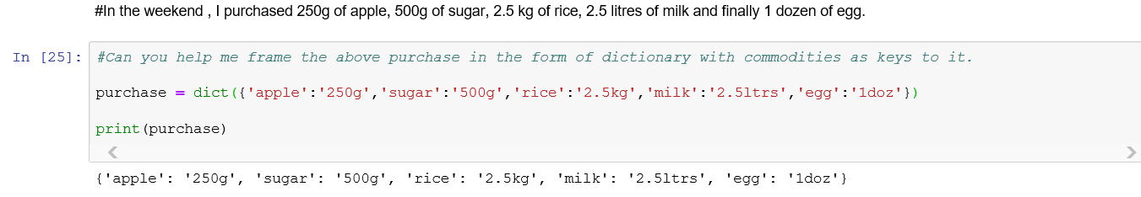

1. I forgot to mention another item, 1kg of atta packet. Can you also add it ?

Solution:

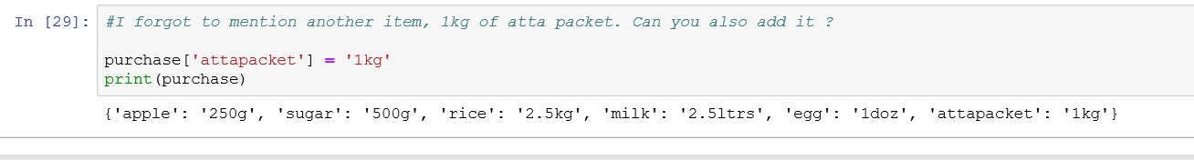

1. Instead of 2kg of rice, I bought only 1kg of rice. Can you change the corresponding value ?

Solution:

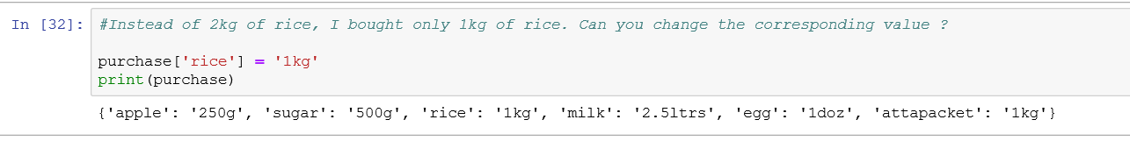

1. Can you list out all these items using a loop.

**Solution:**

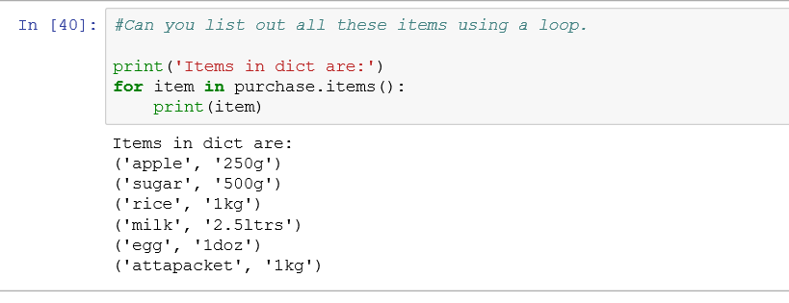

**However, the cost of 1 kg apple is Rs.220, 1 kg of sugar is Rs.43, 1 Kg of rice is Rs. 45, 1 litre of milk is Rs.30 and 1 dozen of egg is Rs. 60.**

Create another dictionary for pricing.

Solution: Is there any way to do it simple?

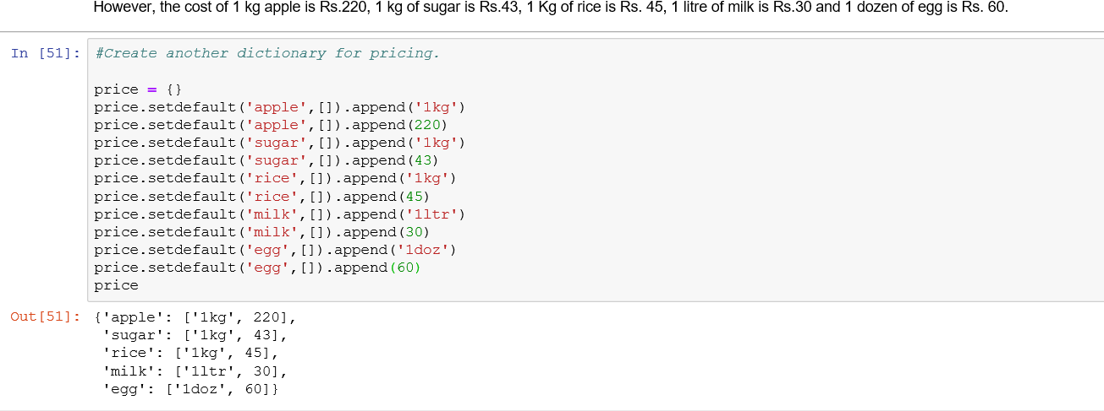

Thereby, prepare a bill for me of the overall cost of the total commodities purchased by using two dictionaries !

**Questions on List**

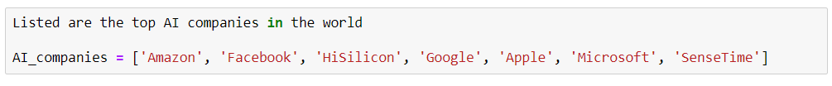

1. Sort the list in ascending order

Solution:

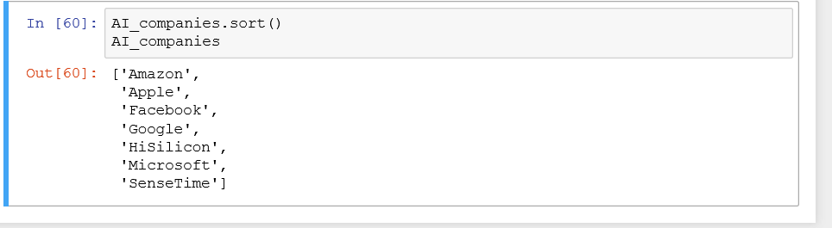

1. Add multiple companies at once 'Nvidia', 'OpenAI' , 'Qualcomm' and 'Reliance' to the list

Solution:

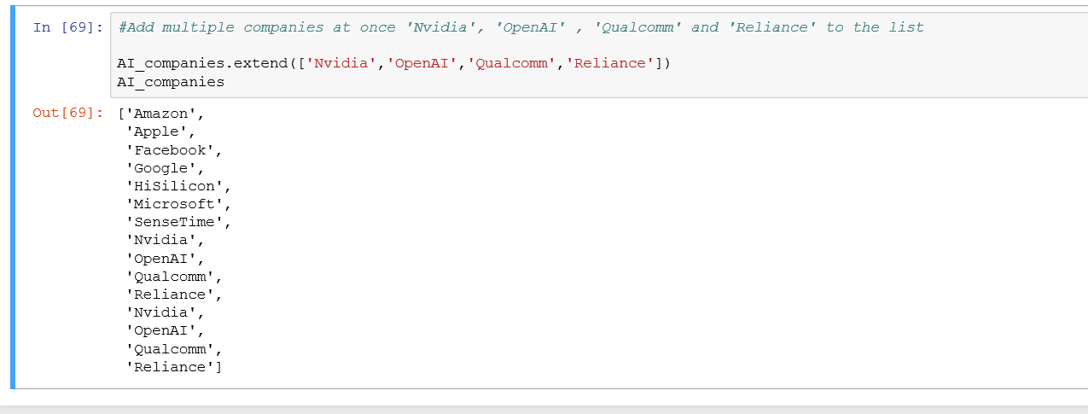

1. Lower the list using List comprehension

Solution:

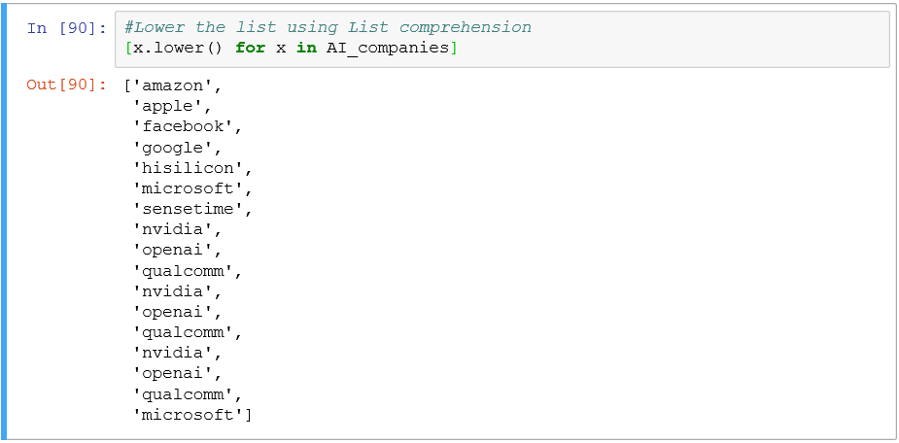

1. Eliminate 'Reliance' from the list

Solution:

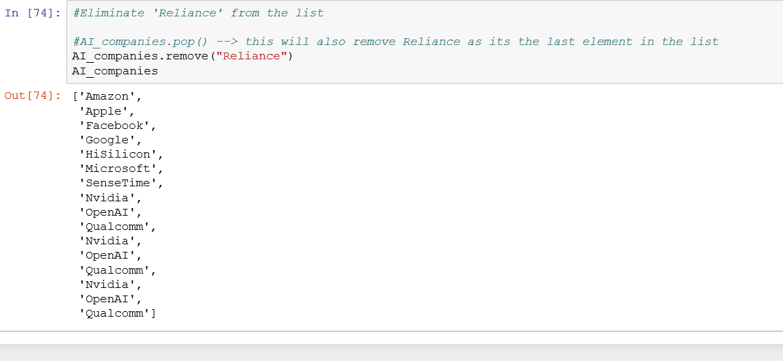

1. Extract 'Facebook', 'Google' and 'Microsoft' using a single command

Solution:

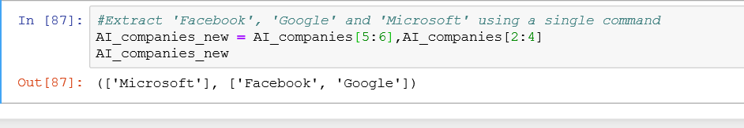

**Questions on Tuple**

(a)Consider the above standard price problem statement and place the prices in the form of the tuple.

Solution:

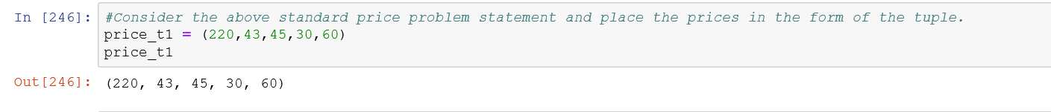

(b)Find out the min and max price among them.

Solution:

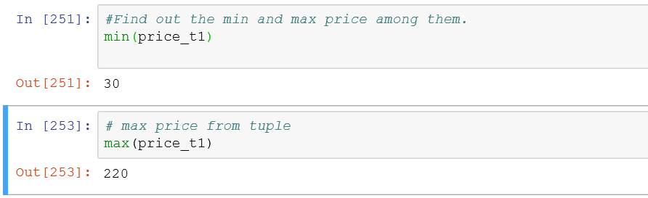

(c)Also, convert the above "AI_companies" list to a tuple.

Solution:

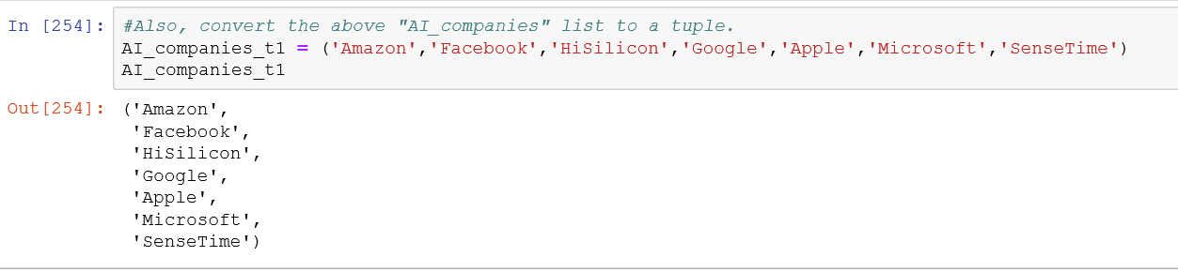

(d)Combine two above tuples to a single tuple.

Solution:

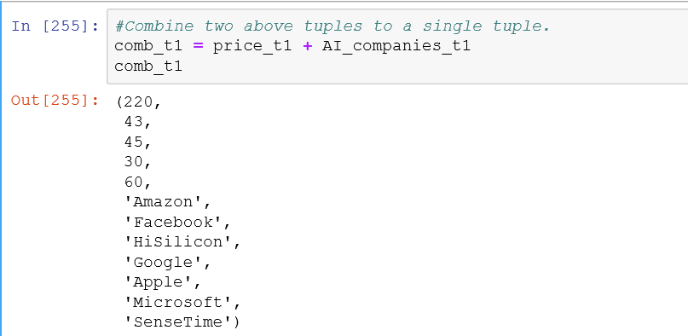

(e)Compare the length of two tuples.

Solution:

